For The Application/

We building a one-side e-commerce web system (API) Using Django and Django RestFramework.

Discussing What the main features Included in the app:

For Company

* The Company can add Product and Category, Brands) (with API)
* The Company delete, editing also products using Django Admin (with API)
* The Company can see Orders
* The Company can make a Track for sending orders to the User

For User /

* The user can create an account in-app
* The user can place an order in the app
* The user can chat with Support
* The user can pay into app (version 2)

Developer/ Mohammed Ashraf Dagga

Social Media/ ([LinkedIn](https://www.linkedin.com/in/mohammedashrafdagga/)) / ([Email](mailto:mohammedashrafdagga@gmail.com))

Table Content

**Section One 3**

**( Building Account Model with Authentication Features) 3**

Authentication Features 4

User Flows 5

**Section Two 7**

**( Building Product Features) 7**

Features 8

User Stories: 8

User Flow: 8

Example Entity Relationship Diagram (ERD): 10

# 

# 

# 

# 

# Section One

# ( Building Account Model with Authentication Features)

## 

### **Authentication Features**

**1. User Registration**

**As a** new user  
**I want to** register for an account  
**So that** I can access the e-commerce platform

* **Acceptance Criteria:**
  + The user can provide a name, email, and password.
  + The system will validate that the email is unique.
  + The system will validate the password and confirm password fields match.
  + The user receives a confirmation email upon successful registration.

**2. User Login**

**As a** registered user  
**I want to** log in to my account  
**So that** I can access my profile and make purchases

* **Acceptance Criteria:**
  + The user can log in using their email and password.
  + The system will validate the user's credentials.
  + The user receives a JWT token upon successful login.
  + The user can use the token to access authenticated endpoints.

**3. Edit User Profile**

**As a** registered user  
**I want to** update my profile information  
**So that** my account information is accurate and up-to-date

* **Acceptance Criteria:**
  + The user can update their phone number, date of birth, gender, address, and profile image.
  + The system will save the updated information to the user's profile.

**4. Change Password**

**As a** registered user  
**I want to** change my password  
**So that** I can ensure my account remains secure

* **Acceptance Criteria:**
  + The user can change their password by providing the old password and the new password.
  + The system will validate the old password.
  + The system will update the user's password if the old password is correct and the new passwords match.

### **User Flows**

**User Registration Flow**

1. **Navigate to the Registration Page**
   * The user accesses the registration page on the e-commerce platform.
2. **Fill in the Registration Form**
   * The user enters their name, email, and password, and confirms the password.
3. **Submit Registration Form**
   * The user submits the registration form.
4. **Validation and Confirmation**
   * The system validates the input fields.
   * The system checks if the email is unique.
   * The system confirms that the passwords match.
   * If validation passes, the system creates a new user account.
5. **Receive Confirmation Email**
   * The user receives a confirmation email upon successful registration.

**User Login Flow**

1. **Navigate to the Login Page**
   * The user accesses the login page on the e-commerce platform.
2. **Fill in the Login Form**
   * The user enters their email and password.
3. **Submit Login Form**
   * The user submits the login form.
4. **Validation and Authentication**
   * The system validates the user's credentials.
   * If the credentials are correct, the system generates a JWT token.
5. **Access Authenticated Endpoints**
   * The user uses the JWT token to access authenticated endpoints on the platform.

**Edit User Profile Flow**

1. **Navigate to the Profile Page**
   * The user accesses their profile page on the e-commerce platform.
2. **Fill in the Profile Form**
   * The user updates their phone number, date of birth, gender, address, and profile image.
3. **Submit Profile Form**
   * The user submits the profile form.
4. **Save Updates**
   * The system saves the updated information to the user's profile.

**Change Password Flow**

1. **Navigate to the Change Password Page**
   * The user accesses the change password page on the e-commerce platform.
2. **Fill in the Change Password Form**
   * The user enters their old password, and the new password, and confirms the new password.
3. **Submit Change Password Form**
   * The user submits the change password form.
4. **Validation and Update**
   * The system validates the old password.
   * The system confirms that the new passwords match.
   * If validation passes, the system updates the user's password.

# 

# 

# 

# 

# 

# 

# Section Two

# ( Building Product Features)

### **Features**

1. **Category and Brand Management**:
   * Admins can create and manage categories and brands via the admin panel.
   * Categories and brands have a many-to-many relationship.
   * Automatic slug generation for URL-friendly names.
2. **Product Management**:
   * Products can be added with attributes such as name, description, price, stock, category, brand, main image, and additional images.
   * Each product is linked to a category and a brand.
3. **Filtering and Search**:
   * Users can filter products by category and brand.
   * Search functionality for products by name and description.

### **User Stories:**

1. **View All Categories and Brands**:
   * As a user, I want to see a list of all categories and their associated brands, so I can explore the product offerings.
   * As a user, I want to see a list of all brands and their associated categories, so I can discover products from my favourite brands.
2. **View All Products**:
   * As a user, I want to see a list of all products available in the system, so I can browse through the offerings.
3. **Filter Products by Category**:
   * As a user, I want to filter products by category, so I can easily find products within a specific type.
4. **Filter Products by Brand**:
   * As a user, I want to filter products by brand, so I can see products from my favorite brands.
5. **Search Products**:
   * As a user, I want to search for products by name or description, so I can quickly find what I'm looking for.

### **User Flow:**

1. **Viewing Categories and Brands**:
   * The user visits the categories endpoint (/api/categories/) to see all categories.
   * The user visits the brands endpoint (/api/brands/) to see all brands.
2. **Viewing All Products**:
   * The user visits the products endpoint (/api/products/) to see a list of all products.
3. **Filtering Products by Category**:
   * The user selects a category from the list.
   * The user visits the products endpoint with a category filter (/api/products/?category_id=<category_id>) to see products in that category.
4. **Filtering Products by Brand**:
   * The user selects a brand from the list.
   * The user visits the products endpoint with a brand filter (/api/products/?brand_id=<brand_id>) to see products from that brand.
5. **Searching Products**:
   * The user enters a search term.
   * The user visits the products endpoint with a search query (/api/products/?search=<search_term>) to find products matching the search criteria.

#### **Example Entity Relationship Diagram (ERD):**

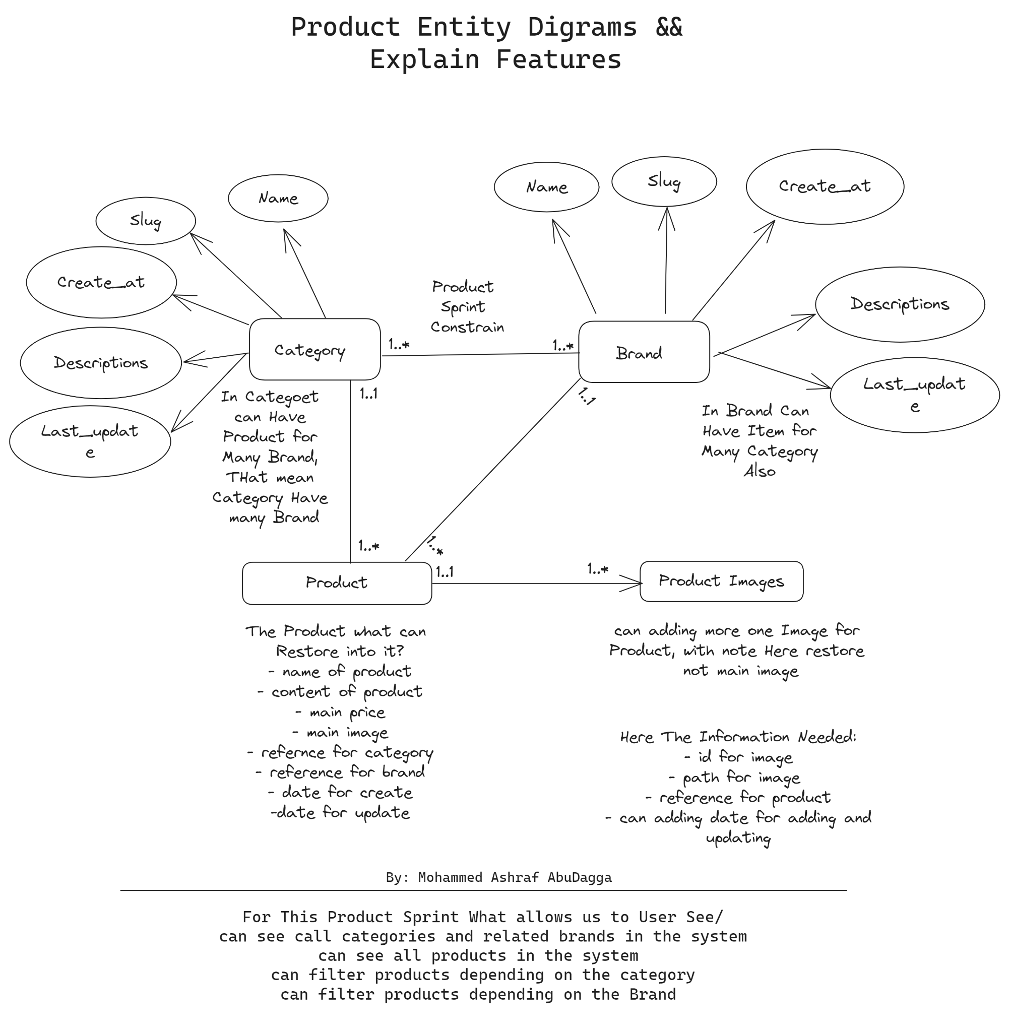

# 

# 

# 

# Section Three

# ( Building Order and Order Items Features)

## **Summary**

We want to create a cart Model to register what the user orders product, for example, the user makes an order with many products, and now wants to register every product in order with quantity and total price for this product for every order for every user

What is the information registered in the cart?

I see the user made an order, product order, qty for this product, and total price.

### **Features**

1. **Create Order**: Users can create an order for any available product in the e-commerce system.
2. **View Orders**: Users can view a list of all their orders.
3. **View Order Details**: Users can view the details of a specific order, including all the products in that order, quantities, and total prices.

### **User Stories**

1. **As a user, I want to be able to order any product available in the e-commerce system**:
   * Users can add products to an order and specify the quantity.
   * The order will calculate the total price and total quantity of the products ordered.
2. **As a user, I want to see all the orders I have made**:
   * Users can view a list of all their past orders.
   * Each order in the list shows a summary including the order date, status, total price, and total quantity.
3. **As a user, I want to see all products in the same order with details such as quantity and total price**:
   * Users can view the details of a specific order.
   * The order details include a list of all products in the order, each with its quantity, price, and total price.

### **User Flow**

#### **Create Order**

1. **Initiate Order**:
   * The user selects products to order from the product list.
   * The user specifies the quantity for each product.
2. **Submit Order**:
   * The user submits the order.
   * The system creates the order and calculates the total price and total quantity.
   * The system saves the order and order items in the database.
   * The system returns the created order details in the response.

#### **View Orders**

1. **Access Orders Page**:
   * The user navigates to the orders page.
2. **View Order List**:
   * The system displays a list of all orders made by the user.
   * Each order entry includes the order date, status, total price, and total quantity.
3. **Select Order**:
   * The user selects a specific order to view its details.

#### **View Order Details**

1. **Access Order Details**:
   * The user selects an order from the order list.
2. **View Order Information**:
   * The system displays detailed information for the selected order.
   * The details include the order date, status, total price, total quantity, and a list of all products in the order.
   * Each product entry includes the product name, quantity, price, and total price.

